**POC-3**

**ABDUR RAHMAN**

IIND YEAR CSE

**local repository in Git**

**Initialize a new Git repository:** Open a terminal (or Git Bash) and navigate to the directory where you want to create your local repository. Then, run the following command:

git init

**Add files to the repository:** After initializing the repository, add the files you want to track with Git. You can use:

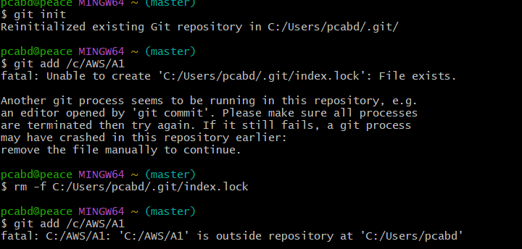

git add <”file name “>

**Commit the changes:** Once you've added the files, commit them to the repository:

git commit -m "Initial commit"

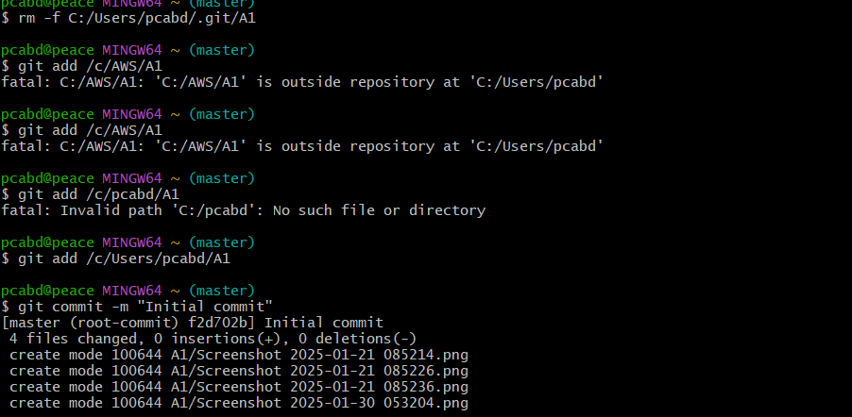

**Check the status:** To check the status of your repository (e.g., which files are staged, unstaged, or untracked), use:

git status

THANK YOU